User Guide

Contents

Menu 2

Navigation Buttons 2

Take Survey 2

View Results 2

Survey Questionnaire 2

Navigation Buttons 2

Number Fields 3

Text Fields 3

Dropdown Fields 3

End of Survey 4

Message 4

Back Button 4

Results Page 4

Glossary 5

Adolescents 5

Unlicensed 5

First Timers 5

Targetables 5

Average Number of Owned BMW Cars 5

Respondent Groups 5

Respondent Groups (%) 6

Preferences by Targetables (%) 6

BMW Models 7

Back Button 7

# Menu

The main menu is the first page to be seen upon opening the BMW-Survey app. From here you will be able to choose whether to submit a survey or view the survey results

## Navigation Buttons

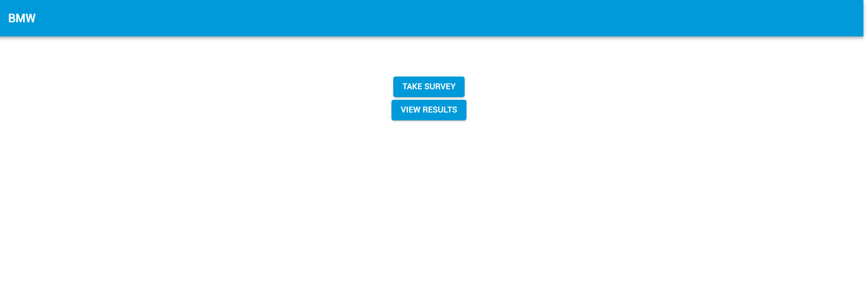

### Take Survey

Clicking the “Take Survey” button will begin the survey process where you will be asked a number of questions about your personal information, driving preferences and purchases of BMW vehicles.

### View Results

Clicking the “View Results” button will take you to the results page where you will be presented with a dashboard of statistical information.

# Survey Questionnaire

The survey questionnaire is accessible via the “Take Survey” button from within the menu page. Once the questionnaire has started you will not be allowed to navigate backwards until the survey is over. It is possible for the survey to end prematurely based on the answers provided – the set of criteria which end the survey prematurely are defined by BMW. The survey results will be stored upon completion of the survey or at a prior stage if the survey ends prematurely. If you close the browser, refresh the page or navigate away from the app prior to survey completion, your response will not be stored.

## Navigation Buttons

 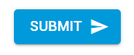

The navigation buttons will allow you to progress throughout the survey. By clicking on the “Next” button you will trigger the application to validate your answer and proceed to the next question. Clicking the “Submit” button (which is presented at the end of the survey) will save your survey responses and navigate to the “end of survey” page.

## Number Fields

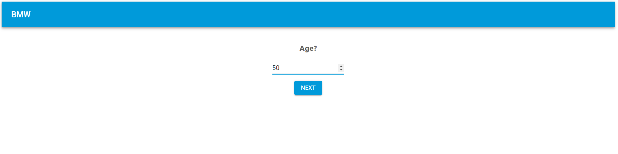

Number fields will restrict your input to only numbers. You may type the number in with your keyboard or use the up/down arrow keys to increment/decrement the value. Alternatively, you may use the mouse to click on the arrows provided on the right-hand side of the field. These fields may have minimum and maximum number limitations, should you try to input a value too small or too large, the app will automatically correct this for you.

## Text Fields

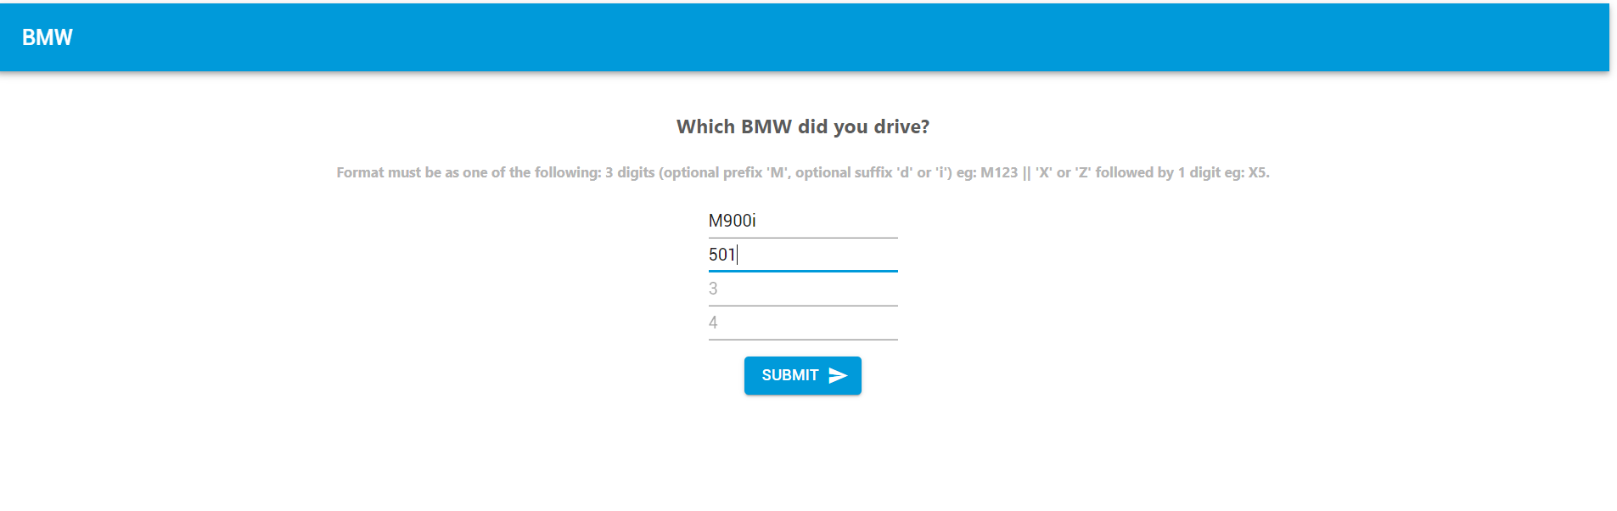

Text fields allow alphanumeric input, however, the final question (see above) has input restrictions which ensure that your input follows the BMW Model name patterns.

## Dropdown Fields

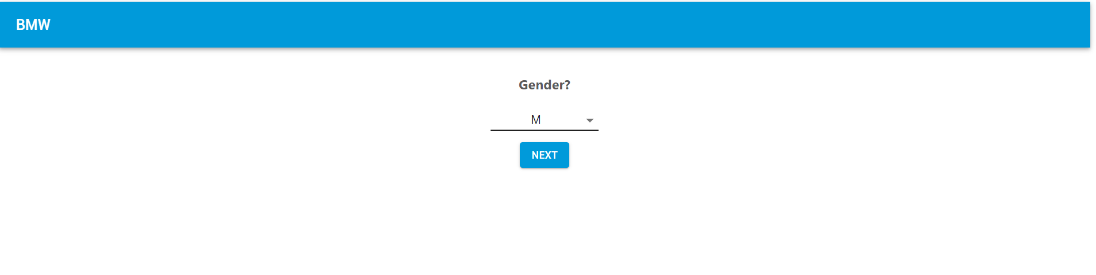

Dropdown fields can be opened by clicking on the arrow on the right-hand side of the field. This will present you with a list of options to choose from.

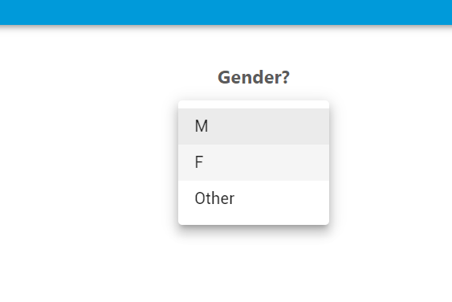

# End of Survey

Once the survey is over, you will be presented with an ending message thanking you for your participation in the survey.

## Message

By default, the message will appear as per the following image:

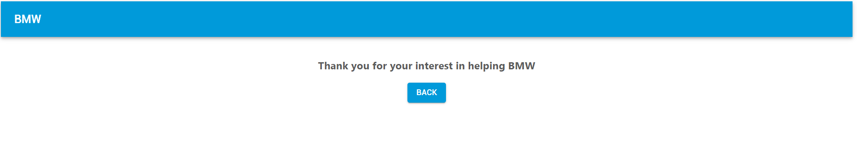

If you enter an age between 18 and 25 and specify that you have a driving licence, you would be presented with a bonus question asking whether it is your first car. Should you answer yes to this question you will be presented with a different ending message as can be seen below.

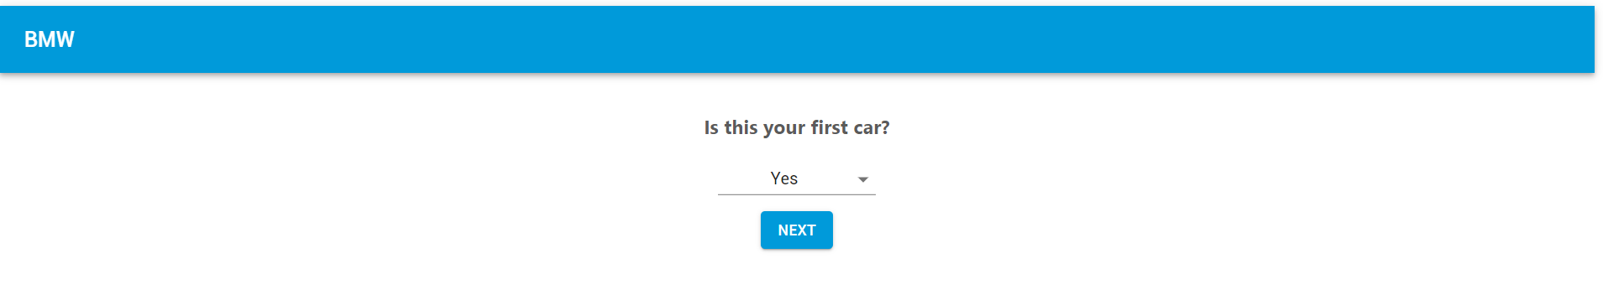

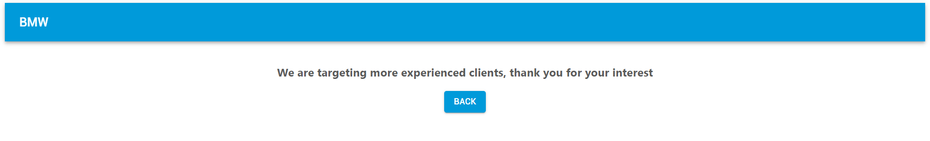

## Back Button

Pressing the back button in this page will send you back to the main menu.

# Results Page

The results page is to be viewed by BMW staff to gather statistical information from the survey responses. You can enter this page by clicking on the “View Results” button in the main menu.

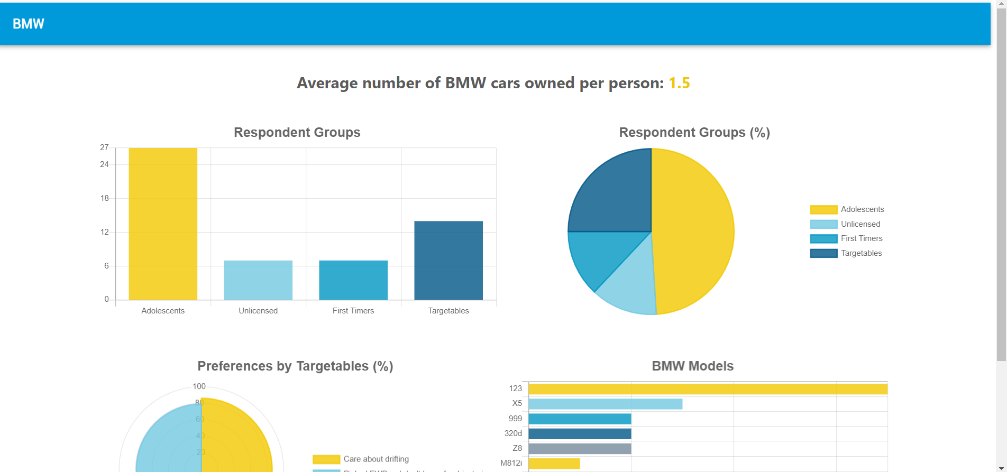

## Glossary

The following terms are used in the results page to better identify the groups of respondents.

### Adolescents

This refers to respondents who are younger than 18 years of age.

### Unlicensed

This refers to respondents who answered “No, I prefer using other transport” when asked if they own a driver’s license.

### First Timers

This refers to respondents who answered “Yes” when asked if they have just purchased their first car.

### Targetables

This refers to the customers who are either older than 25 with a driving license or those who are between 18 and 25 with a driving license who have owned other cars in the past.

## Average Number of Owned BMW Cars

At the top of the dashboard you will see the average number of cars owned by the respondents.

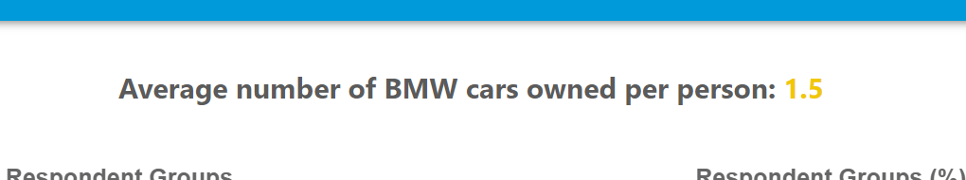

## Respondent Groups

A vertical bar chart is used to represent the number of respondents grouped by the following categories: Adolescents, Unlicensed, First Timers, Targetables. Hovering over the bars will present the exact number for the group.

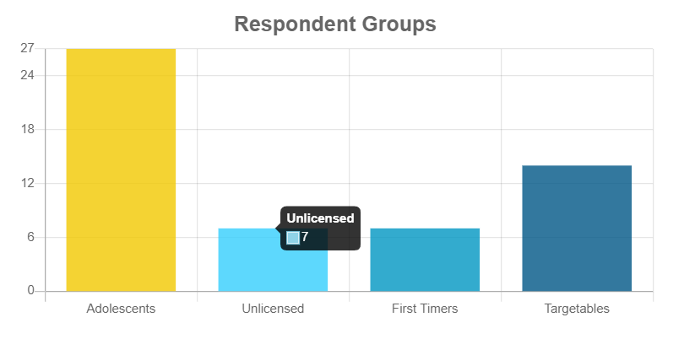

## Respondent Groups (%)

A pie chart is used to represent the percentage of respondents grouped by the following categories: Adolescents, Unlicensed, First Timers, Targetables. Hovering over the sections will present the exact percentage for the group.

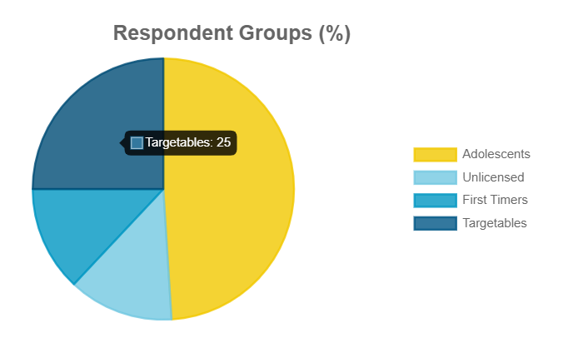

## Preferences by Targetables (%)

A polar chart is used to represent the percentage of targetable respondents grouped by the following categories: “Care about drifting” and “Picked FWD or I don't know for drivetrain”. Hovering over the sections will present the exact percentage for the group.

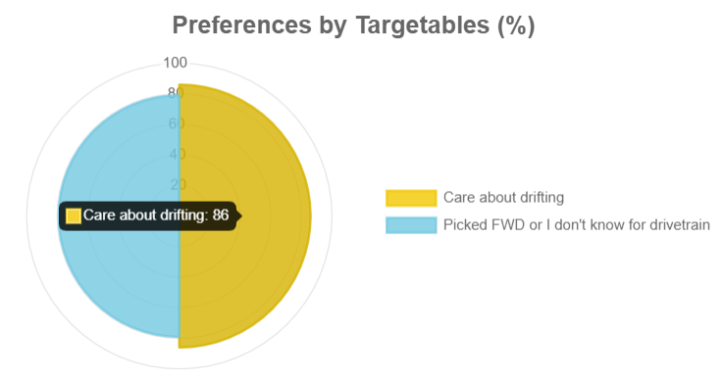

## BMW Models

A horizontal bar chart is used to represent the number of BMW Models entered grouped by the model names and sorted in descending order. Hovering over the bars will present the exact number for the group.

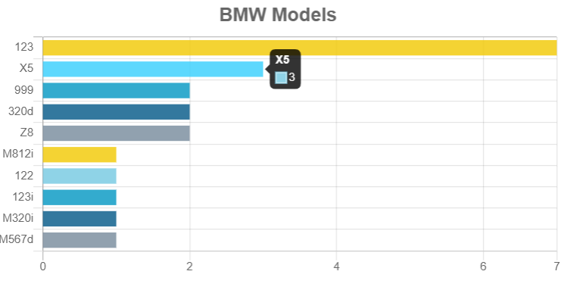

## Back Button

You may leave the results page and navigate back to the main menu by clicking on the back button located at the bottom of the page.

